Steps to recreate the ADOxx models
- Metamodel
  - Create metamodel concepts – domain, relations and attributes
    - Under __D-construct__ create Node
    - Under Node, create a new class: ProcessStep
    - Under Node, add 2 new classes: StartEvent and EndEvent
  - Recreate the following concept tree:
__D_construct__
- Node
  - StartEvent
  - EndEvent
  - ProcessStep
- Actor
  - Buyer
  - Seller
- BusinessEntity
  - Shoe
  - Order
  - Payment
  - Shipment
  - Add GraphRep to each element for graphical representation, e.g.:
GRAPHREP
FILL color:purple
ELLIPSE rx:0.6cm ry:0.4cm
  - Define relationship classes
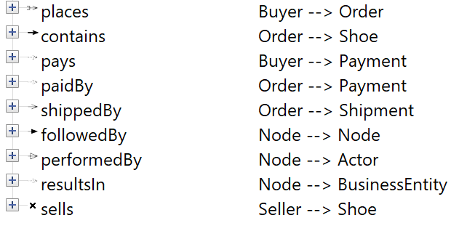
  - Add GraphRep to the relationship classes, e.g.:
GRAPHREP

PEN color:black w:0.05cm
EDGE

PEN color:black
START
POLYGON 4 x1:-0.15cm y1:0.15cm x2:0.15cm y2:0.15cm x3:0.15cm y3:-0.15cm x4:-0.15cm y4:-0.15cm

END
POLYLINE 3 x1:-0.4cm y1:0.15cm x2:0cm y2:0cm x3:-0.4cm y3:-0.15cm
  - Create the following model type:
GENERAL order-of-classes:custom

MODELTYPE "Reselling app"

INCL "Seller"
INCL "Buyer"

INCL "StartStep"
INCL "EndStep"
INCL "ProcessStep"

INCL "Shoe"
INCL "Order"
INCL "Payment"
INCL "Shipment"

INCL "places"
INCL "contains"
INCL "pays"
INCL "paidBy"
INCL "shippedBy"
INCL "followedBy"
INCL "performedBy"
INCL "resultsIn"
INCL "sells"
  - Add new user for the experimentation library
  - Add the following metamodel constraints to the ProcessStep’s class cardinality
CARDINALITIES min-outgoing:1 min-incoming:1
RELATION "followedBy" FROM_CLASS "EndStep" max-incoming:0
RELATION "followedBy" TO_CLASS "StartStep" max-outgoing:0
  - Add the following class cardinality to StartStep
CARDINALITIES max-objects:1 min-objects:1
RELATION "followedBy" max-incoming:0 max-outgoing:1
  - Add the following class cardinality to EndStep
CARDINALITIES max-objects:1 min-objects:1
RELATION "followedBy" max-incoming:1 max-outgoing:0
  - Add the following line to the library attributes modelling part
CHECK_CARDINALITIES before-save:1 after-modeling-action:1
  - Define the following attributes for the classes
Class | Attributes
Node | id  name  description
StartStep | triggerType
EndStep | resultStatus
ProcessStep | stepType  duration
Actor | actorId  name  email
Buyer | shippingAddress
Seller | rating
BusinessEntity | entityId  createdAt  status
Shoe | brand  model  size  condition  price
Order | amount
Payment | paymentMethod  amount
Shipment | courier  trackingNumber  estimatedDelivery

  - Add attribute constraints
  - Define the AttrRep of the classes that makes it possible for the user to interact with the attributes
- Model
